Promoted by The Willesden Cycling Club

Willy Warmer
ETYMOLOGY:
From Willesden and Warmer, something to keep the January cold out

Venue
Chalfont St Peter Community Centre, GR TQ000911. Enter Landranger Grid “500000,191073” into www.streetmap.co.uk for a detailed map.

*** Please don’t park in the small Community Centre car park which is used by day visitors to the centre
– see directions below for parking ***

Directions if heading N on A413 (e.g. from M25 & M40 jn1): Be aware a popular car boot sale takes place on a Saturday morning at the Denham M40/A40 Roundabout and congestion can be expected. Please allow extra time. Continue on A413 to second roundabout (just after going under bridge).
By car: Take 1st exit $ Chalfont St Peter Centre, shortly 2nd exit at mini-roundabout $ Gold Hill and immediately R $ ‘Parking’ into Church Lane.
A large car park is on the right (see below). Take the path as shown opposite to reach the Community Centre.
By bike: Take 2nd exit $ Amersham, then after 200m L (green $ ‘Chalfont St Peter Community Centre’) to the Community Centre.
Directions if heading S on A413 from Amersham: Continue on A413 to roundabout at entrance to Chalfont St Peter.
By car: Take 3rd exit $ Chalfont St Peter Centre, shortly 2nd exit at mini-roundabout $ Gold Hill and immediately R $ ‘Parking’ into Church Lane. A large car park is on the right (see below). Take the path as shown opposite to reach the Community Centre.
By bike: Take 4th exit (i.e. back the way you came) $ Amersham, then after 200m L (green $ ‘Chalfont St Peter Community Centre’) to the Community Centre.

Car Parking: The Council have recently introduced a Controlled Parking scheme and there are double yellow lines everywhere. The Pay and Display Car Park detailed above charges £2 for up to 4 hours and £3.50 for over 4 hours. Free on Sundays and Bank Holidays.

Public Transport: The nearest train station is Gerrards Cross on the London Marylebone line (but check for engineering works!); the 06:27 service from London will get you to the start line in plenty of time. Trains back into town depart at 16, 31 and 52 minutes past the hour. The closest London Underground station is at Uxbridge (Metropolitan and Piccadilly lines), a 10 kilometres ride via the A4020, A40 and A413.

On Arrival
- Please make your way to the Community Centre and collect your brevet card from the Controller. Any last minute route amendments will be advised at this time (also see “Updates” on the next page).
- The Community Centre will be open from around 7am. Free tea & coffee will be available, along with cereal, bread and jam.
- If you are coming by bike and want to leave any bags behind, see me at the start, and I can look after them during the day (at your own risk). Don’t leave bags in the Community Centre – other groups will use it during the day.

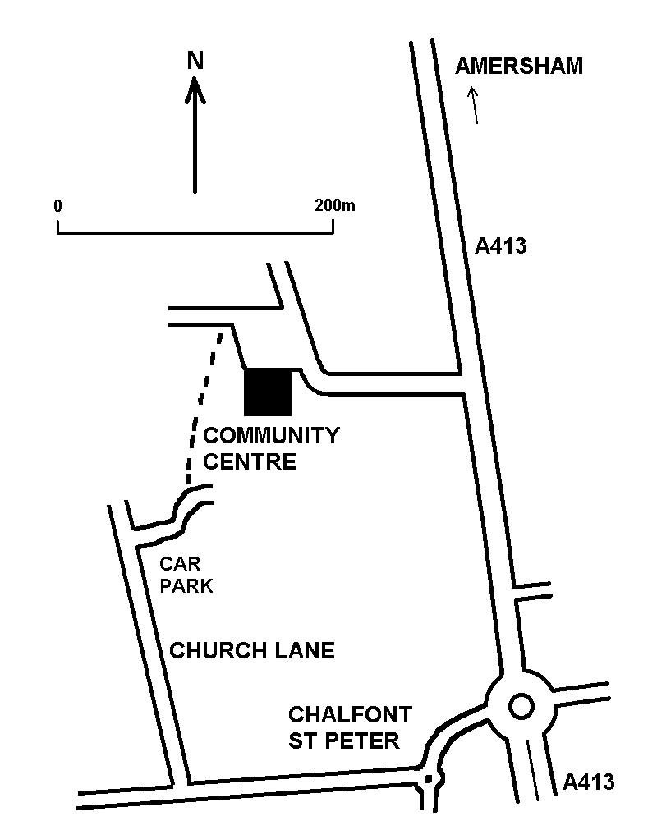

The Ride
Bike: Due to the time of year and the risk of inclement weather, mudguards are recommended. Do not underestimate the route. You are strongly encouraged to carry good lighting as the later sections include unlit roads which you will have to navigate in the dark, so don’t forget your headtorch!

Route: The route is intended to be a winter audax which may suffer from poor weather and short days, so the emphasis is on a fast route, good roads and not too much climbing . At the same time you will get to see some undulating country roads, so be prepared!

Route Options
Poor Weather Cutouts
Hopefully we shall have good weather on the day however it is a January event so the route includes some ‘Poor Weather’ options which follow main road to avoid country lanes which can be prone to snow/ice or flooding. These are clearly marked on the routesheet and gpx files.

Controls and Refreshments:

Pangbourne Control: The main control is the “Costa Café on the High Street.where you can collect a sticker for your Brevet. If the café is busy collect a receipt from the supermarket or ATM.

Hungerford Control: A long term favourite meeting point for Audax events. Collect a sticker or if the Café is busy, a receipt from anywhere in Hungerford. There is a large Supermarket on the left before the bridge in the High Street.).

Kingsclere (info) has a Co-op selling sweets and snacks in Swan Street opposite the church.

Winnersh Control:
Collect a sticker from the Java Café at the back of the car wash (was petrol station) on left at junction with A329. The café normally shuts at 6pm but is staying open till 7pm for us. Later riders should make a supermarket sweep at Sainsburys on the right as you approach the A329, or try the burger van on the corner (but get a receipt!).

The Finish
- Please make your way to the Community Centre and register that you have completed the ride. Make sure you have completed your name and address, and have signed your Brevet before handing it in.
- There will be food and drinks are available at the finish of the tea, cake variety, plus some simple hot snacks of the beans on toast variety at a nominal cost.
- There are washrooms and toilets, but no showers.
- Please respect the other users of the hall. Leave your bikes outside, and avoid crowding the lobby around the kitchen area.

If it all goes horribly wrong …….
Alas, once you leave the HQ you are on your own; there is no rescue service, and it can be difficult to return to the start using train services. However, you can get trains from Pangbourne, Hungerford & Reading to Slough, and Chalfont is approx 13km north from Slough up the B416 towards Gerrards Cross. The alternatives is to take the train to Paddington and then back out to Gerrards Cross (but will involve transiting yourself and bike from Paddington to Marylebone station).

IF YOU DO ABANDON PLEASE PHONE ME ON THE NUMBER GIVEN ON THE BREVET CARD. If you don’t call I’ll be sitting at the Arrivee worried about you.

Have fun and be safe.

Paul Stewart

Forza Squadra!
07974 670931 paudax@gmail.com

Information: This is an Event for experienced cyclists who will be aware of the following procedures:

- Whenever possible, familiarisation with the route before the event. Ensuring competence and fitness to complete the course, roadworthiness of the machine and possession of adequate cycle-repair equipment, spares and skills.
- During the event, riding safely, according to the rules of the road and personal capabilities and taking responsibility for personal feeding, warm clothing and rest periods, especially at night.
- Personally deciding not to continue if feeling unwell or too tired
- As with any journey on public roads being aware of and allowing for highway design and maintenance, other users (especially horses), busy traffic conditions, the state of disrepair of the surface (potholes, trenches, ironwork etc.), debris and obstructions of all kinds, poor or non-existent lighting on night sections and oncoming headlights.
- As some roads could be high and exposed, with hills that could be steep and strenuous, carrying adequate food, drink, clothing and equipment for any conditions; preparing the machine (and rider) and carrying spares and tools – and knowing how to use them.
- In the event of bad weather, making a personal decision over starting or continuing; also being equipped to deal with bad conditions.
- Making private arrangements if back-up or rescue facilities are wanted, although if this is the case undertaking this ride at all should be reconsidered.
- Being adequately rested before traveling home after finishing

As with all Audax UK rides you are on a private excursion on the public highway and subject to the law of the land, so ensure that you are fully self-sufficient and capable of handling all conditions as found on the day.
You are, for the duration of the event, on a private excursion on the public highway and responsible for your own conduct at all times.
You should abide by Audax UK Regulations for this ride and be insured via your relevant Membership of CTC/BC/AUK, or apply for Temporary AUK Membership and pay the Fee of £2.00; (for all other requirements additional, adequate personal travel insurance will be necessary).
Please ensure that your Brevet Card is completed with all details, including contact in case of an emergency
Chalfont – Pangbourne
Good Conditions Route
See below for Poor Conditions Route
0.0 | R with care from HQ onto A413
0.2 | 3E RB $ Village Centre
0.4 | R (2E RB) at mini RB
0.7 | R and Immed R onto Nichol Rd  Brown Sign Chalfont Leisure Centre
1.4 | R @ T onto Grove La
1.6 | L onto Welders La
3.3 | L @T $ Seer Green
5.0 | R @ T onto A40, BEACONSFIELD SA through several RB  Pick up route at 12.2 below

Chalfont – Pangbourne
Poor Conditions Route
0.0 | R with care from HQ onto A413
0.2 | 3E RB $ Village Centre
0.6 | 1E MRB
0.9 | R with care @ T no $
 | ¢ thru Gerrards Cross town centre
3.4 | R @ X on A40, BEACONSFIELD  SA on A40 through several RB
12.2 | 1E RB $ WOOBURN GREEN
13.9 | L @ T onto Town La
15.4 | R (2E RB) $ Marlow  BOURNE END, WELL END
16.4 | R (2E RB) $ Marlow
17.8 | L (1E RB)  Continue SA to central Marlow  (RB with Market Square / Obilisk)
21.9 | SA (2E RB) $ A4155  ¢ to HENLEY where
33.7 | R (2E MRB) $ Wallingford  Immed L onto Badgemore Lane
34.0 | R @T then  Immed L onto Crisp Rd
34.2 | L onto Hop Gardens (School)
34.7 | R @ T no $
40.1 | L @ T (B481)
42.0 | After new housing estate on RHS,  Sharp R onto Stoke Row Rd  $ Village Hall
42.4 | L onto Gallowstree Rd, $ CANE END
45.6 | R @ T on A4074, $ Crowmarsh
47.2 | L, $ B4526, Goring  Continue to T Junction

Good Conditions Route
See below for Poor Conditions Route
48.8 | L @ T $ Goring Heath
48.9 | R $ Hill Bottom
51.2 | L @ T onto B471, $ Pangbourne Steep Descent. Cross river at toll bridge (cyclists free!)
53.5 | 1E MRB to: PANGBOURNE CONTROL  Collect sticker from Costa Café in the high street or receipt from anywhere.  Note you can access the Costa Café rear terrace through the car park on the right.

Poor Conditions Route
 | 48.8 |  | R @ T $ Goring  L $ Pangbourne (B471)  continue to Pangbourne Control
Pangbourne - Lambourn
53.6 |  | L from Control, 1E MRB (eff. SA)
53.7 |  | L (1E MRB) $ Basingstoke  Immed R $ Yattendon by Church
58.9 |  | R @ T $ YATTENDON
67.6 |  | L @ T No $
68.4 |  | 3E MRB onto Priors Court Rd  $ CHIEVELEY
71.3 |  | L onto School Rd (after Red Lion Pub)
73.9 |  | L @ T $ B4994 Newbury
74.2 |  | R $ Winterbourne
75.4 |  | R $ Boxford
78.6 |  | L @ Tri with tree
78.9 |  | R @ T $ EASTON
84.8 |  | R @ T no $, GREAT SHEFFORD
85.0 |  | Soon L, $ EAST GARSTON
92.0 |  | LAMBOURN INFO CONTROL  Church Noticeboard on LHS, shortly before crossroad

Lambourn - Hungerford
92.3 | L @ X onto High Street
95.9 | L @ T $ Newbury
97.3 | R $ Chilton Foliat
102.6 | L @ T $ Hungerford
105.0 | L @ T $ Newbury
105.5 | R (2E MRB) to Town Centre
105.7 | HUNGERFORD CONTROL  Check in with the Controller in the  Tutti Pole Café on RHS after river bridge.  If busy get receipt from other cafes or shops (there is a large supermarket on LHT immed before railway bridge).

Hungerford - Kingsclere
Continue up Hungerford High St passing under railway bridge
105.9 | L (1E MRB) onto Park St $ Station BR @ Tri by bridge, ¢ KINTBURY
110.8 | in Kintbury, Fork R onto Newbury St  $ HAMSTEAD MARSHALL
112.9 | R on LHB $ East Woodhay
116.9 | ¢ straight ahead into BALL HILL  R $ Woolton Hill (after Ball Hill Garage on Left)
119.7 | RL STGX over A343 $ PENWOOD
122.3 | Cross bridge over A34

Good Conditions Route
See below for Poor Conditions Route
122.4 |  | L @ T, $ Burghclere
123.7 |  | R onto Spring La, $ Ecchinswell
124.6 |  | R @ T, $ Ecchinswell
124.9 |  | L @ T
128.0 |  | L @ T, ECCHINSWELL
128.3 |  | R by P.H. $ Kingsclere
131.1 |  | R onto Newbury Rd  ¢ to Kingsclere Info Control by Church  Toilets and Shoppe in Swan Lane
131.4 |  | KINGSCLERE INFO CONTROL  Church noticeboard in Swan Lane
Poor Conditions Route
122.4 | R @ T $ WHITWAY
125.0 | L $ OLD BURHCLERE
131.3 | After KINGSCLERE boundary sign  R onto Bear Hill $ Overton
Bear L, L @ T onto Swan St
Carpark, Toilets and Shoppe on RHS (Church)
131.4 | KINGSCLERE INFO CONTROL  Church noticeboard in Swan Lane
Kingsclere – Winnersh
131.4 | Continue on George Street to
132.0 | RL over A339 $ Aldermaston, KNOWLE HILL
135.2 | R on LHB after B&W Chevrons  small $ Wolverton Nurseries
136.5 | L @ T onto Wolverton Rd no $
Good Conditions Route
See below for Poor Conditions Route
136.6 | R @ Tri shortly after AXMANSFORD  sign onto Ham Lane (no $)
138.1 | R @ T no $  Shortly L, STONEY HEATH, RAMSDELL
141.2 | L @ X onto Monk Sherborne Rd  $ CHARTER ALLEY
142.0 | L on RHB onto Old Chapel Lane
142.1 | R onto Pamber Rd $ Pamber End
143.5 | L @ T $ Pamber
144.9 | RL over A340 $ BRAMLEY  Continue to Bramley Level Crossing

Poor Conditions Route
See below for Poor Conditions Route
(distances approximate)
139.1 | R @ T $ Basingstoke
140.1 | L $ TADLEY onto Shaw La
142.4 | R (3E RB) $ PAMBER END onto A340
145.7 | L $ Bramley  Easily Missed - look for concrete bollards on verge on left hand side

149.9 | Bramley Level Crossing
150.0 | Immed after LC,  L onto Bramley La  $ STRATFIELD SAYE
153.7 | RL STGX onto New Street
155.7 | R @ X (Tri on right) $ Heckfield
158.0 | 2E RB over A33 $ RISELEY
158.3 | L $ B3349 RISELEY

Riseley - Winnersh
158.7 | R onto Odiham L  Immed L onto Part Lane
161.3 | R @ T no $
162.9 | L onto Swallowfield Rd  $ ARBORFIELD CROSS
166.3 | 2E RB onto Sindlesham Rd  $ WINNERSH
168.2 | SA (2E RB) then
168.9 | L (1E MRB) to
169.6 | WINNERSH CONTROL  Main control is the Java Café in the car wash (was petrol station) on LHS of junction with A329. Java closes at 6pm, later riders go to Sainsburys

Winnersh – Chalfont
169.6 |  | Back to route and cross A329 onto B3030 [Robinhood La]
171.0 |  | On blind LHB, R Immed L (eff SA)  $ St NICHOLAS CHURCH
172.3 |  | L@T $ Twyford  Immed R $Ruscombe
173.5 |  | R @ T onto B3018 $ Bracknell
174.1 |  | L onto Hungerford La no $
176.4 |  | SOX $ PALEY STREET
178.3 |  | L (1E RB) onto Howe La  $ PALEY STREET
180.4 |  | R @ T $ Maidenhead,  ¢ PALEY STREET
181.8 |  | L @ T onto A330 $ Maidenhead
182.7 |  | R onto Forest Green $ Windsor
 | 183.4 |  | L onto Moneyrow Green,  ¢ HOLYPORT
 | 184.3 |  | Attention! Fork R by Large Tri no $  R @ T onto Holyport Rd
 | 185.5 |  | L @ T (1E MRB)  Immed R after underpass $ Bray
 | 188.7 |  | R (3E RB) onto A4
SA @ RB and cross Maidenhead Bridge
SA @ RB (entrance to new estate)
 | 189.5 |  | L @ TFL by car sales $ Taplow Onto Berry Hill and climb...
 | 197.8 |  | R @ T $ Littleworth Common
 | 193.3 |  | L @ T $ Burnham Beeches
 | 199.6 |  | L onto A355  Move to RHL to…

199.9 | R @ TL, immed 1E RB onto Hedgerley La
202.4 | L @ T onto Hedgerley lane
205.1 | L @ TL onto B416  $ GERRARDS CROSS
206.5 | SOX A40 $ CHALFONT ST PETER
208.2 | L onto Lower Rd (before RB)
208.5 | R (2E MRB) onto High St
208.6 | L (1E RB) onto A413
209.0 | L into Chalfont Centre ARRIVEE
Key
- L:Left, BL: Bear Left,
- R:Right, BR:Bear Right
- L/R @ T/Tri: Turn at T Junction orTriangle
- L/RHB: Left or Right Hand Bend
- SOX: Straight over X Road
- ¢ Continue on, SA Straight Ahead
- LR/RL STGX: Staggered X Road
- 1/2/3/4 E RB/MRB: Take Exit on Roundabout or Mini RB
- $ Town : signpost for Town
- TOWN : Enter Town / Pass Boundary Marker

