“Roaches” Audaxes – 16th May 2026
General Information
HQ: Dore, Old School Hall, Savage Lane, S17 3GW
HQ will be open from around 6:30am, tea, coffee, toast, muesli available (free). There’ll also be food at the finish.
Parking: there is some parking in the HQ car park. Plenty of parking around Dore, but please be considerate of locals, and be prepared to park a few hundred metres from the HQ. If you head north from the HQ, along Causeway Head Road, there’s lots of parking – the road is wide and all the houses have driveways.
E-Brevet:
If you haven’t used E-Brevet before, I’d highly recommend downloading the app. It makes checking in at the controls a doddle, as it saves having to answer questions / get receipts. Once you’ve downloaded the app, you need to go into settings and put in the event code 26-xxx, then “download brevet”.
One thing to be aware of – you still need to navigate yourself to where the control point is located (or within a couple of hundred metres). It will tell you how far away you are if you’re not there.
Avoiding the A515:
At ~74km (on the 100) and 174km (on the 200) there’s a 1km section on the A515. This can be a bit unpleasant, although it’s never felt dangerous to me. You can avoid this by turning left in Hartington up Hyde Lane, then right again to Parsley Hay.
The only drawback with this version is that, even though it has a much shorter section of riding on the A515 (~50m), you do have to turn right across the on-coming traffic – see picture below.
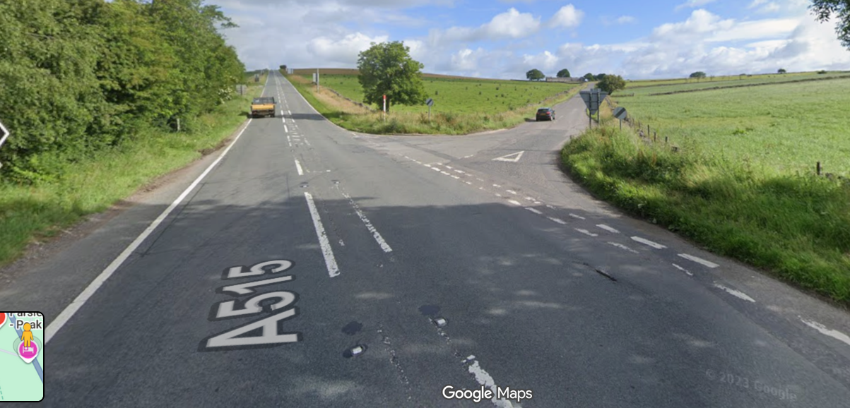
Alternative finishes:
Unfortunately there are no quiet routes back to Sheffield from the final control in Youlgreave. The quietest is probably going up Rowsley Bar, but I suspect that won’t be especially popular!
The main issue is the A621 from Baslow to Owler Bar. It’s definitely become a fairly unpleasant road on a busy Saturday afternoon. Other than Rowsley Bar, the other option is to come back up Froggatt, i.e. reverse the outward few kilometres.
The easiest alternative finish is to continue through Youlgreave & Alport and trun right onto the A6, then through Chatsworth and up Froggatt. It adds a few kilometres, but is the usual way I come back from Youlgreave. You are obviously free to plot your own route back – there is a ‘lanes’ route back to Baslow, but it’s a bit convoluted and adds a fair bit of distance.
Control information:
Goostrey (200km only) – effectively an open control (i.e. any receipt). Pastimes café are a cycling-friendly café and enthusiastic about the event. Please use them if you can – however, they are quite a small place and in the past we somewhat overwhelmed them. About 500m further along on the right, just off the main road is The Trading Post. This is a general store, and has a hot food counter, tea / coffee etc, and really good pre-made sandwiches (better than your average petrol station fare). There are some benches on a grassy area outside, so quite a nice place to sit.
Note that if you’re using e-brevet, the control point is set for Pastimes café.
George Hotel, Youlgreave (all distances) – The George Hotel is the ‘official’ control and they’re aware of, and happy to support the event. The George doesn’t open until mid-day, so some of the faster 50km & 100km riders may get to Youlgreave before it opens.
There are other options in Youlgreave – the Village Store & Team Room (open 9am – 5pm), and Fountain Store Bakery (9am – 2pm). I’m happy to have receipts from anywhere in Youlgreave (note that Youlgreave & Youlgrave are interchangeable).
I can definitely recommend the Fountain Store Bakery café!
Re-supply & other stopping options
50km: Calver Crossroads (12km) & Monyash (29km)
100km: Calver Crossroads (12km), Monyash (29km), Tagg Lane Dairy (31km) – great if it’s ice cream weather, Longnor Store & Cobbles Café (newly re-opened) (36km), Hartington (69km).
200km: Lots of options – you should all be experienced enough to sort yourselves out. There’s not much between Longnor (36km) and Goostrey (80km), but that’s the only section without regular re-supply points.
Organiser contact details:
Joe Le Sage
jjlesage@hotmail.com
07864 575912

